**Yaba Mediterranean Grill**

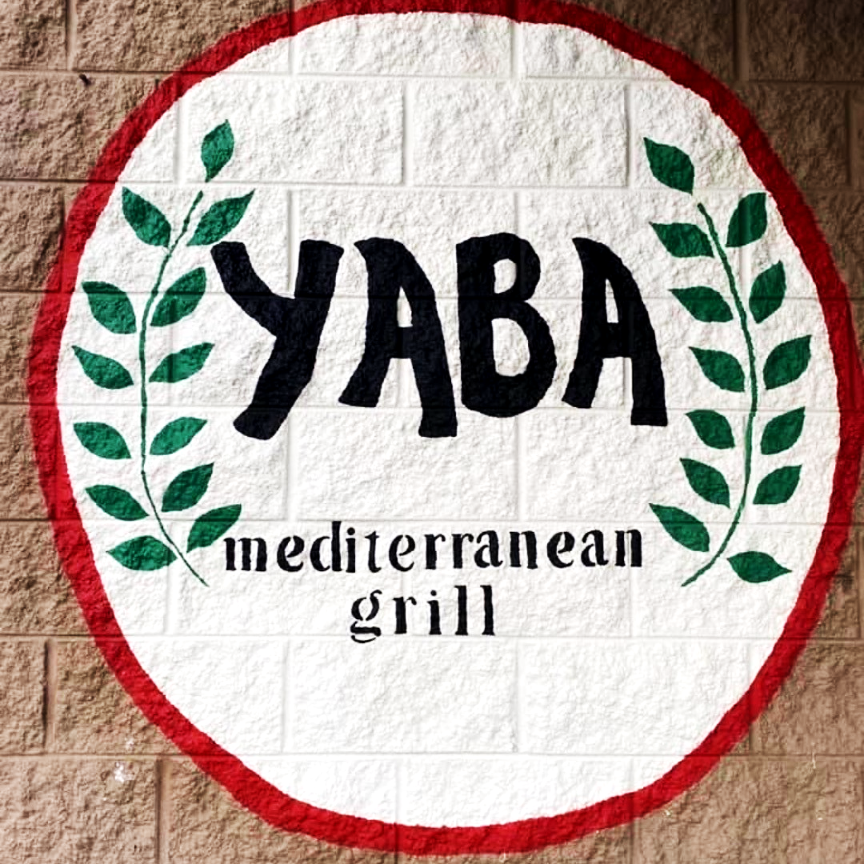

**Team 3**

**Sprint Review and Retrospective 1**

**February 10, 2022**

**By: Alexander Waller, Liam Alexander, Sabrina Knott, & Karrington Evans**

**Table Of Contents**

**Section 1**

1. Executive Summary……………………...……………………………………….………3
2. Company Background and Current Environment…………………………………………4
3. Problem Analysis (BPA, BPI, BPR)....................................................................................5
4. Proposed Systems Objectives……………………………………………………………..6
5. Constraints………………………………………………………………………………...7
6. Expected Benefits…………………………………………………………………………8
7. Use Case Diagram……………………………………………...………………………….9
8. Context Diagram…………………………………………………...…………………….10

**Section 1**

# ***Executive Summary***

The information presented in Sprint 1 will cover team three’s vision for Yaba’s new and improved ordering system. We decided on working with Yaba because we feel it's important to support our local businesses, and we intend on Yaba implementing our proposed system.

In section one we will be discussing Yaba’s company background, current environment, problem analysis (BPA, BPI, BPR), the proposed system objectives and constraints, the expected benefits, context diagram, and a use case diagram.

Yaba has just opened up a second location in Raleigh, North Carolina. Their current system doesn’t allow for an order to be placed to the Raleigh location, and also doesn’t display the Raleigh menu. The Raleigh menu has slight differences in food offered and completely different pricing. We have proposed to build an ordering system for Yaba where a customer will have the ability to select between the two locations when ordering and the appropriate menu will be displayed. Also, we intend on adding a login page where customers can make accounts. When logged in, their most recent orders will be displayed and their location will already be set. Hopefully, this will increase revenue for Yaba and establish a sense of loyalty with customers due to the ability to make an account. Our group intends on finishing as early as possible since the Yaba owner wishes for this to be implemented as soon as possible!

# 

# ***Company Background***

Yaba is a family owned restaurant that serves Mediterranean food at an affordable price in Greenville, North Carolina. It was established in 2020 and is located at 1201 Charles Blvd, Greenville, NC 27858. Majd Thaher is the owner in Greenville, North Carolina and is a current student studying public health. The success of Yaba in Greenville has allowed for the family to quickly open another location in Raleigh this past year. Yaba’s mission statement is to bring authentic shawarma and Mediterranean cuisine, from their home land Palestine, to North Carolina as a healthier restaurant option. They have a promise to prepare healthy and delicious food, all while maintaining the bold flavors of Middle Eastern cuisine in an atmosphere that is clean and welcoming to all.

# 

# ***Current Environment***

Yaba’s current environment involves two restaurants in different locations with menus differing mainly in price. Customers currently order on Yaba’s website, choose what they want, and the location selection is only for Greenville currently. Orders come through on an app called square restaurants and then are automatically sent to their Wireless bluetooth printer. There’s recently been a lot of confusion on the Yaba website due to the new location. Customers in Raleigh will place an order on the website but don’t realize they’re sending orders to Greenville. Furthermore, that order in Greenville goes to waste. This has made customers unhappy, caused unnecessary stress for current workers, and is hurting the Yaba’s potential revenue. Majd has emphasized that customer feedback has asked for an account option on Yaba’s website to be made instead of the newsletter!

## 

# 

# ***Problem Analysis***

Yaba Mediterranean Grill has two locations in Raleigh and Greenville, North Carolina. Currently, only Greenville residents are able to order online through their website. Yaba has two different locations with also two different menu prices. The Raleigh location is losing potential business due to customers who prefer to order online. The owner, Majd, also voiced his concern of customers confusing the Greenville menu prices online with the actual prices of the Raleigh location. Another concern of Majd’s is the inability to save customer information on their website. There are many recurrent customers of Yaba. With time being money, this would make orders and transactions a lot easier for the business and collect more sales by saving time. Our team will be improving the business processes at Yaba for a BPI project.

# 

# 

# 

# 

# 

# 

# ***Proposed System Objectives and Features***

The system our team is proposing for Yaba is an additional location option with a menu that has the corresponding prices for the Raleigh location on their website. This will allow the customers of Raleigh to be able to order online and eliminate any customer confusion in the future for this location. This system will also provide a customer login on the website. Having this feature on the website will allow every customer who creates a login on the website to have their information saved to make ordering online more efficient. Business will also run more smoothly by already having recurrent customer information in the database.

# 

# ***Constraints***

The critical constraint for this project is time. The owner of Yaba, Majd, has requested for this system to be ready as soon as possible. The website will be down temporarily as we implement the new system. The timing limits the scope of the project because the scope also has to be rational in order for the system to be done as soon as possible.

# ***Expected Benefits***

***Minimize calls to restaurant***

Yaba currently not having a website for their Raleigh location means that it’s harder for residents there to purchase their food. The only method available to them currently is to call in to place their order and then go to the restaurant to pay and pick up their food. This makes it more difficult for the employees at the Raleigh location since it takes time and focus away from their customers that are dining in while they answer the phone calls and take down the orders. They have to manually write down the customers’ information and orders while trying to keep up with everything else. They also may miss potential customer phone calls while attending to other customers at the restaurant, which decreases their business and efficiency. Having a website to order online at the Raleigh location would save them a lot of time, and they would be able to receive the customers customized orders with their information, allow them to pay online, and receive this information through their computer.

***More customer traffic and awareness (improving sales during COVID)***

Along with minimizing the number of phone calls Yaba’s Raleigh location currently receives, having a website with both the Greenville and Raleigh locations would also allow Yaba to have more customer traffic and increase their sales. Oftentimes people like to browse the menu and see prices along with pictures before going to a restaurant they’ve never been to before. Having a website to be able to view and even order their food would allow more people to have access to the restaurant and to increase awareness by word of mouth or sharing their website link. Giving people the option to have their food delivered to them or have the option for carside delivery increases their sales as well during the COVID-19 pandemic as this allows people to have little to no contact with others. The website would improve customer accessibility to order from Yaba on one website with the ability to select the location to order from.

***Accurate menu prices for both locations***

Customers being able to select which location they’re at will display different menus for each respective Yaba location. The Greenville and Raleigh locations have different prices due to the areas, and the website would allow customers to view the actual prices they would be paying before they order their food. Along with the different menu prices, each location also has different closing times. The new website would allow the customers to view all this information in one place for further ease of access.

***Increased Revenue***

The current website only allows customers to order from Yaba’s Greenville location and doesn’t allow the location to be changed. This has led to customer confusion and frustration since customers from the Raleigh location try to order food, and the order gets sent to the Greenville location without them realizing this. Fixing this issue would keep customers coming back and leave good reviews for the restaurant, which in turn increases the number of new customers visiting Yaba and generates more revenue for both locations.

# ***Use Case Diagram***

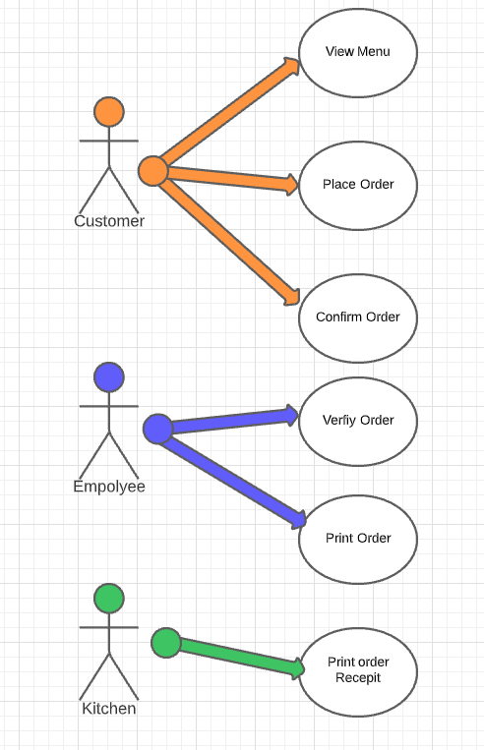

# 

# 

# 

# 

# 

# ***Context Diagram***

